**Final Project: Sensor Fusion and Object Tracking**

Main Steps of the project

1. Implementation of Extended Kalman filter
2. Implementation of track management (Track state, track score, track initialization and track deletion)
3. Implementation of single nearest neighbor data association and gating.
4. Sensor Fusion by implementing the nonlinear camera measurement model and a sensor visibility check

Step 1

Goal: To implement an EKF to track a single real-world target with lidar measurement input over time

**Set Parameters:**

training_segment-10072231702153043603_5725_000_5745_000_with_camera_labels.tfrecord

show_only_frames = [150, 200]

configs_det = det.load_configs(model_name='fpn_resnet')

configs_det.lim_y = [-5, 10]

exec_detection = []

exec_tracking = ['perform_tracking']

exec_visualization = ['show_tracks']

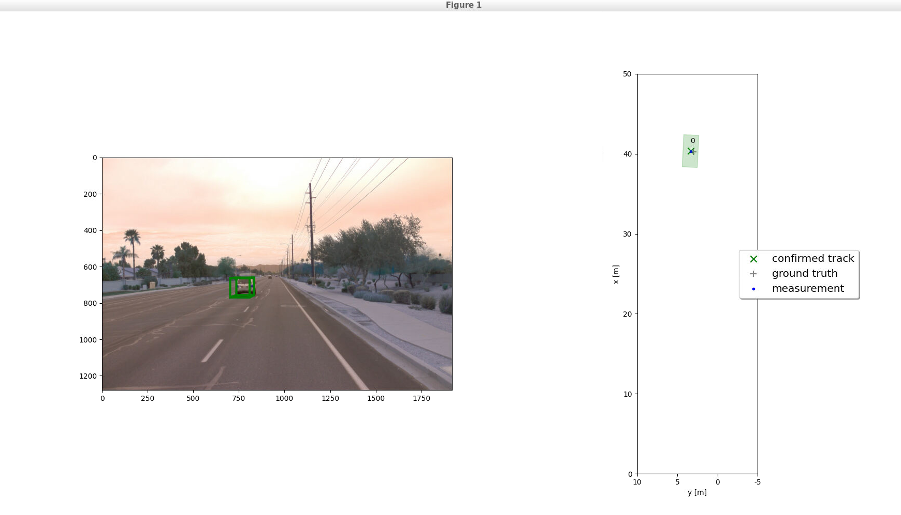

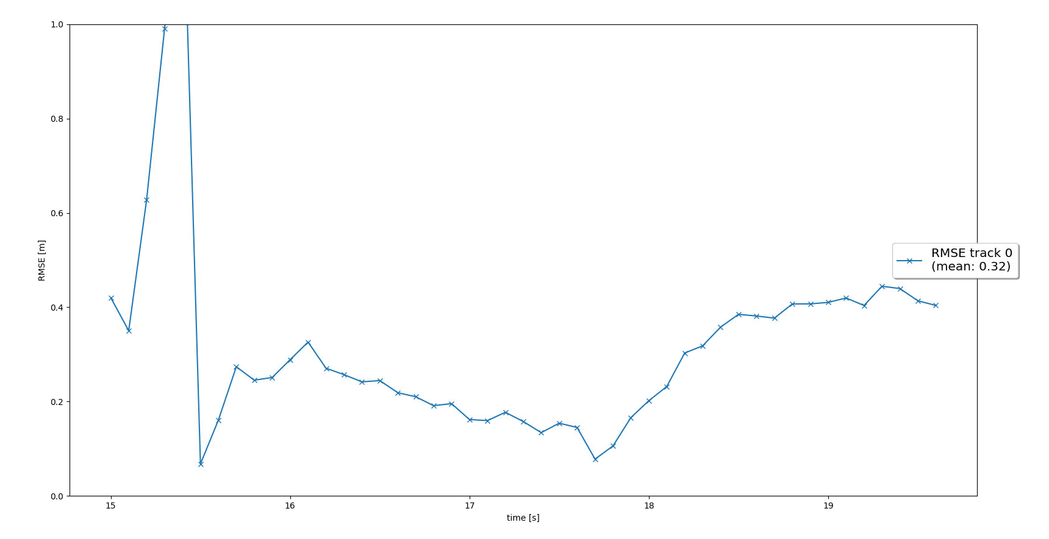

Result: The mean RMSE has a value of 0.32.

Step 2:

Goal: Implementing track management to initialize and delete tracks, set track state, and track score.

**Set Parameters:**

show_only_frames = [65, 100]

configs_det.lim_y = [-5, 15]